MY BASKET – SMART BASKET USING IoT

Sachin Tiprale Department of Computer Engineering

Wagholi Pune Pune, India

Samrudhi Jiddewar Department of Computer Engineering

*Wagholi Pune*

Pune, India

Mandar Chatorikar Department of Computer Engineering

*Wagholi Pune*

Pune, India

Prajwal Autade Department of Computer Engineering

*Wagholi Pune*

Pune, India

Mrs .Sunita Nandgave

**Abstract**

The smart shopping cart is a technologically advanced cart equipped with an integrated chip, a barcode reader and a battery system. This innovation enables users to conveniently exit supermarkets without the need for traditional checkout counters, effectively reducing time consumption during the shopping process. The primary focus of proposed system is to develop and present a solution for expediting the checkout process in supermarkets by introducing a smart shopping cart that empowers users to self-checkout, thus improving overall shopping center efficiency and extending production time.

The Internet of Things (IoT) kit, which includes a barcode scanner, is included into the smart shopping cart to help achieve this goal. This system automatically identifies and registers products placed within the cart by utilizing an ultrasonic sensor. By seamlessly integrating these technologies, aim to streamline the shopping experience, reduce waiting times at checkout counters, and enhance the overall shopping journey for consumers.

**KEYWORDS** :- Supermarket, Barcode-Scanner , Sensor (ESP 8266) , IoT , EM-18 Reader Module etc.

1. **INTRODUCTION**

The primary objective of this project is to enhance the shopping experience for customers by introducing an efficient and user-friendly system. This improvement can be achieved by implementing a straightforward process of attaching RFID tags to products and incorporating an RFID reader with an LCD display on the shopping cart. Through this system, customers will gain access to real-time information regarding the price of each scanned item, the cumulative total cost, and concise product details. The implementation of this system will result in time savings for customers, reduce the need for additional manpower within the shopping mall, and lower costs associated with product management.

1. **HARDWARE’S USED**
2. **ARDUINO UNO**

Here we use Arduino uno. It is open source microcontroller board that helps create interactive projects giving smart solutions by automation. It is based on the processor ATmega328p. It also comes with a variety of input and output pins that can be used to connect different electronic components.

1. **LCD DISPLAY**

Liquid crystal displays (LCDs) have gained widespread use in various technological applications, serving as the primary visual component in devices such as calculators and laptop computer screens. In this project, we focus on the integration of the LCD1602 Parallel LCD Display, which offers a straightforward and economical solution for incorporating a 16×2 Black on RGB Liquid Crystal Display into your specific project requirements. This cost-effective display module proves to be a valuable addition for a range of applications.

1. **BUZZER**

Audio signaling devices, such as beepers or buzzers, come in various forms, including electromechanical, piezoelectric, and mechanical types. In this context, we are focusing on the 3.3V-5V DC Electronic Part Active Buzzer Module, which belongs to the category of electronic audio signaling devices. This specific module is designed to generate audible alerts or signals and operates within the voltage range of 3.3V to 5V DC, making it a suitable choice for electronic projects and applications that require this functionality.

1. **RED & GREEN LIGHT**

Here we are going to use Red and green LED light which has some following specifications:

* Diameter :- 3 mm.
* Glow Color :- Red, Green.
* Forward voltage :- 2.2 V to 2.4 V.
* Peak Reverse Voltage :- 5 volts.

1. **Push Button**

These are very small light duty SPST Single Pole Single push buttons that are NO Normally Open. This are only rated up to 50mA at 5V DC and are intended for low-voltage operations such as providing digital inputs to microcontrollers. When we remove the products from basket we have to push the button then scan the product then only we can remove the product.

1. **ESP8266**

The NodeMCU is an IoT platform that employs the Lua scripting language and is an open-source solution. This module is equipped with the CH340g USB to TTL IC and is built upon the ESP8266 framework. It combines various functionalities on a single board, including GPIO, PWM, IIC, 1-Wire, and ADC.

Key features of the ESP8266 include its open-source IoT platform nature, ease of programmability, low cost, and straightforward implementation, making it a versatile choice for IoT applications.

1. **EM-18 READER MODULE**

The EM-18 RFID Reader is a compact and user-friendly RFID reader module that comes with a built-in antenna. The only limitation to be mindful of is the 2mm pin spacing.

In this we need EM18 module with 5V DC supply,125 Hz Read Frequency,EM4001 read tag compatible and reading distance is equal to 5 meters. In this we need compatible tags of 125KHz EM4100 Tags.

It has some applications like smart access control System , Attendance system.

1. **RFID TAG**

An RFID tag has a radio antenna installed on a microchip that has a 12-byte unique identification number. For this, EM4001 RFID Tags with a 125Hz frequency are required.

1. **Table**

|  |  |  |  |
| --- | --- | --- | --- |
| Sr. No | Component | Quantity | Approx. Price |
| 1 | ESP8266 | 1 | 400-600 |
| 2 | 20x4 LCD  Display | 1 | 300-500 |
| 3 | EM-18 RFID  Module | 1 | 500-1000 |
| 4 | RFID  Tag | 1 | 500-700 |
| 5 | Led | 2 | 150-200 |
| 6 | Buzzer | 1 | 100-200 |
| 7 | Push Button | 1 | 100-200 |

1. **METHODOLOGY**

* Smart basket is a IOT based model which is developed for convenient shopping and to save the time of customers.
* Log in: User must login to the smart basket website.
* Customer will get the information about the product and their ratings.
* When customer starts actual buying of products then:-
* Data Collection: Data collection for the project is the RFID card of the product to scan the price of the product.
* Data Preparation: After obtaining and scanning the RFID card of the product, the price of the product will be added to the account.
* Product Analysis: After adding the price of the product we have to analyze the bill whether it is showing the accurate billing or not.
* RFID Scanner: The product is scanned by the RC522 RFID Reader, which also adds the item to the cart, computes the item's price, and totals the weights.
* Cashier Management System: It allows management to access and manage the cart of customer and payment transactions. All information will save at management server.

1. **IOT BASED SMART SHOPPING CART CIRCUIT DIAGRAM**

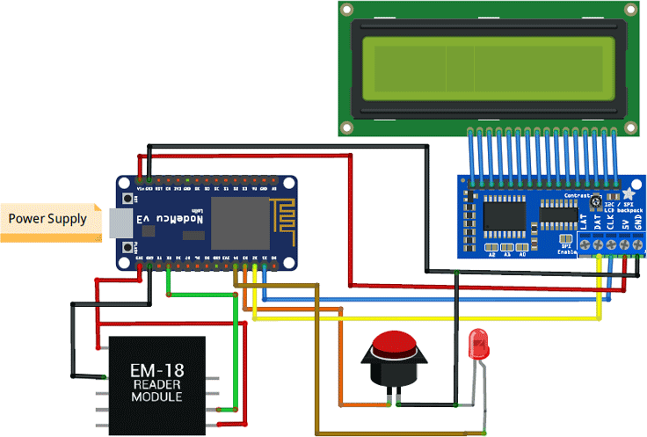

1. **CONCLUSION**

One such technology that links diverse devices in a network is the Internet of Things, which is a turning point in the era of the smart world. This technology, which enables consumers to shop effectively, is included in smart shopping carts. A cutting-edge technology that gives people around the world access to a seventh sense is the Internet of Things. The planet will become intelligent by 2020 when around 1 billion objects are connected. In order to prevent lengthy checkout lines, this smart shopping cart enables customers to scan the item they wish to purchase, which updates the bill automatically. Cart-to-cart communication is another intriguing feature of this smart shopping cart that enables users to shop with friends and family at the same time.

1. **REFERENCES**

# List of papers/books/websites etc refered for project:

Title: Smart basket for big basket. Author: Kumar Ashish, Dongare Pranal.